PHYSICS REVISION

Calculating Speed/Velocity

- Find the average speed of a jet that flies from Brisbane to Cairns (1700km) in 2hrs.

- James completed a 100 m race in 11.7 seconds. What was his average speed in m/s?

- What is the average velocity of a plane that flies 1000 kilometres north in a time of 4 hours?

- A boy walked 8km due East, then another 6km due North. It took him 3 hours.

- Calculate his average speed.

- Calculate his average velocity.

Calculating Distance/Displacement

- Claire ran for 43 seconds at a speed of 7 m/s. How far did she go?

- If you drive at 100 km/hr for 6 hours, how far will you go?

- If you run at 12 m/s for 15 minutes, how far will you go?

- Calculate the distance and displacement between the start and finish for each of the following:

- Travel 8km West, then 6km South
- Travel 5km East, then 3km North, then 5km West.
- Travel 7km East, then 24km South

Calculating Time

- A dog runs up and down the yard at an average speed of 20 km/h, covering a total distance of 37 km. How long was he running around for?

- Calculate how long it will take to drive 30km at an average speed of 90km/h.

- Bob ran 330 metres at a speed of 6m/s. How far did both Bob run?

- A bullet travels at 850 m/s. How long will it take a bullet to go 1 km?

Interpreting Graphs

- Describe the motion for each of the following displacement-time graphs:

d

t
aa
ba
ca
da

- The graph shows the distance a pizza delivery driver has driven against how long he has been away from the pizza restaurant.
Delivering Pizzas
0
0.5
1
1.5
2
2.5
3
3.5
1
3
5
7
9
11
13
15
17
19
21
23
25
Time (Minutes)
Distance Traveled (Km)
0 2 4 6 8 10 12 14 16 18 20 22 24 26
a) How long did it take the driver to arrive at his first delivery?
b) If he is paid $16 for each delivery, how much did he earn on this delivery run?
c) How far did he travel on this delivery run?
d) How long did it take Mack to do the delivery run?
e) Calculate his average speed.

- The distance-time graph below shows a race between 3 people:

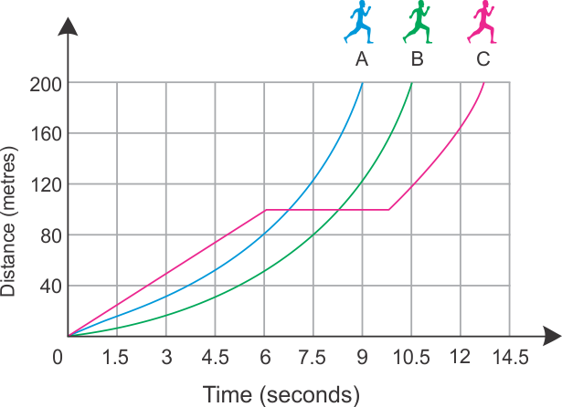

(i) Which runner won the race?

(ii) How far was the race?
(iii) Which runner stopped for a rest and how long did he stop for?
(iv) How long did the runner B take to complete the race?
(v) Calculate the runner A’s average speed.

- The graph below shows the distance-time graph of three moving objects: A, B and C.

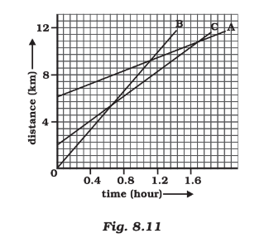
(a) Which of the three travelled the fastest?
(b) Which of the three had the biggest head start?
(c) Which of the three went the greatest distance.
(d) What does it mean when the lines cross each other?
(e) Are all three ever at the same point on the road?
(f) How far has C travelled when B passes A?
(g) How far has B travelled by the time it passes C?
(h) How long does A travel for?

Calculating Acceleration

- A car accelerates from 1 m/s to 23 m/s in 9 seconds. Calculate the acceleration.

- A toy rocket accelerates from the launch pad to a speed of 56m/s in a time of 6.3s. Calculate its acceleration.

- A toy racing car goes at speed of 6m/s. By the end of the straight it is travelling at a speed of 24m/s. If it takes 3s to travel the length of the straight find its acceleration.

- Which has the greater acceleration: a car going from rest to 32m/s in 12s, or a motorcycle accelerating from 12m/s to 26m/s in 3s?

Newton’s Laws

- State Newton’s 3 Laws

- A water filled balloon with a mass of 1kg accelerates at 10m/s². What force was required to do this?

- A loaded coal wagon with a total mass of 20tonnes (20 000kg) is pushed by a force of 300kN (300 000 newtons). What is the value of the acceleration?

- A 7.5N force is applied to a football, generating an initial acceleration of 10m/s². What is the mass of the football?

- Explain, using Newton’s Laws:
- How someone is able to pull a tablecloth out from under a dining setting without the plates, cups and cutlery moving.

- Why it is dangerous to have loose objects inside a moving car.

- Which has the most inertia – a stationary car or a stationary truck?

Kinetic Energy and Potential Energy

- How much kinetic energy does a 5g bullet have if it is travelling at 100 m/s?

- How much potential energy does a 80kg man standing on a diving board 8m high have?

- What is the velocity of a 48 kg dog running across a lawn with 216 joules of kinetic energy?

- The GPE of a 15 kg object is 294 joules. How high the object above the ground?

- The KE of a bowling ball travelling at a speed of 4 m/s is 50 joules. What is its mass?

- Use the diagram of a rollercoaster below to answer the questions that follow:

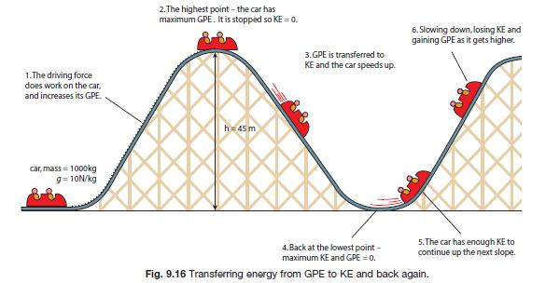

- Calculate the Potential Energy of the roller coaster car at the highest point
- How much PE and KE does the car have at the lowest point?
- Calculate the velocity of the roller coaster car at the lowest point?
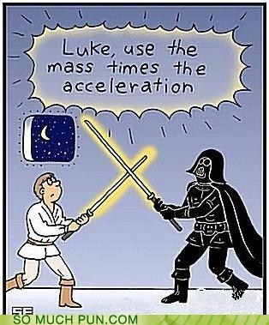
Year 10 Science
PHYSICS
FORMULAS

d

÷ ÷

s x t

d

÷ ÷

v x t

1. Speed = distance s = d
time t

2. Velocity = distance v = d
time t

V_{f} – V_{i}

÷ ÷

a x t

3. Acceleration = final velocity - initial velocity a = v_{f}-v_{i}
time t

F

÷ ÷

m x a

5. Force = mass x acceleration F = m x a

KE

÷ ÷

½m x v²

6. Kinetic Energy = ½ x mass x velocity² KE = ½ x m x v²

PE

÷ ÷

mg x h

7. Potential Energy = mass x g x height PE = m x g x h

